New ability to declare a non-confiscated account in Ziraat Bank

T.C. Ziraat Bankasi A.S currently has been activated in the transitional status of POL 1182/2014 regarding the declaration of non-confiscated accounts of the Greek taxpayers. This means that our customers, from 02.01.2021 are able to declare the IBAN of their account (salary, pension or other) at T.C. Ziraat Bankasi A.S as non-confiscated according to the legal provisions and the limits established by the Greek state. In order to declare, the customer should log-in to his account in AADE (Taxisnet) with his tax credentials as below by following the link: https://www.aade.gr/polites/akatashetos-logariasmos .

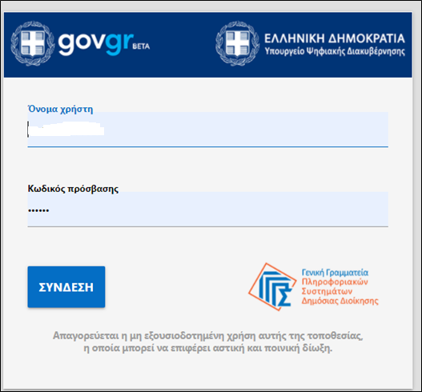

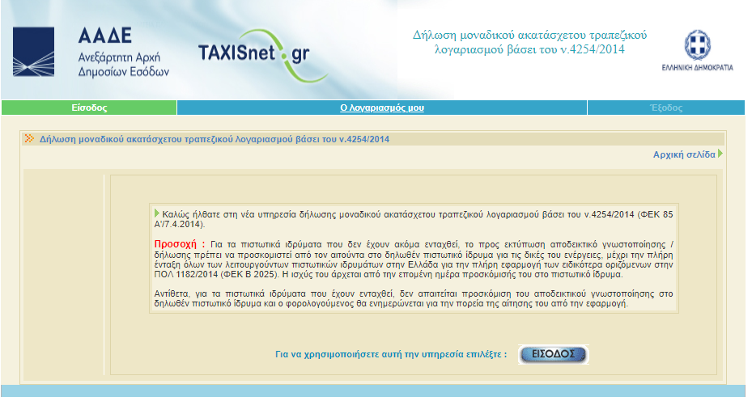

After logging in the customer will be prompted to insert his/hers IBAN in the form as below without the GR prefix.

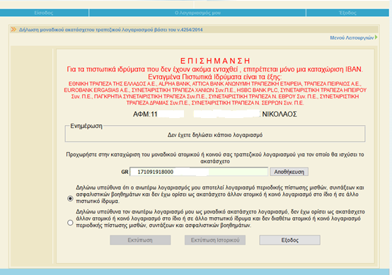

When pressing save, the system will return this warning that the account cannot be changed if the Bank is not a full member of the non-confiscated accounts module. The customer can safely press OK as despite this fact the account can change. After pressing ok, the IBAN is saved and the customer must press PRINT in order to print the relevant declaration. This declaration must be submitted in one of our Bank’s Branches in order for our personnel to declare this IBAN as non-confiscated in our Banking system and have the protection of the relevant legislation. The printout of the system is like the following:

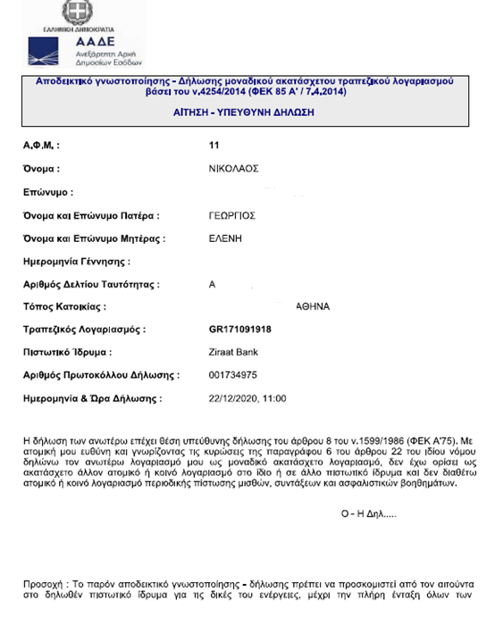
If the customer later on wishes to alter this submission and declare a different IBAN in a different Bank, this can be achieved by calling the help desk of AADE at the tel. number 213-1621000 and declare the new non-confiscated account. Note that only one non-confiscated account is allowed to be active. Customers are required to inform our Bank by printing and submitting / sending the declaration for deletion of the IBAN that they have previously declared as non-confiscate

