**Embargoes & Sanctions Policy Statement**

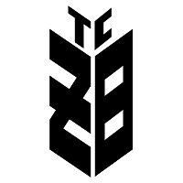T.C. Ziraat Bankasi A.S Athens Central Branch has decided, to fully mitigate the inherent sanctions, embargoes and country risk by prohibiting any transactions with any Entities, Individuals or Financial Institutions that are located in the below-mentioned countries and not engage in any possible business that may derive from these jurisdictions:

|  |
| --- |
| 1.Islamic Republic of Iran |
| 2.Syrian Arab Republic |
| 3.Democratic People's Republic of Korea |
| 4.Crimean Region of Ukraine |
| 5.Republic of the Sudan |
| 6.Republic of Cuba |
| 7.Republic of the Union of Myanmar |
| 8.Democratic Republic of the Congo |
| 9.Federal Republic of Somalia |
| 10.  Republic of Yemen |
| 11.  Bolivarian Republic of Venezuela |
| 12.  Donetsk Region of Ukraine |
| 13.  Luhansk Region of Ukrain |

Based on the above information, the Bank employees will deny any transaction from and to the above mentioned countries or may deny transaction or business that may be considered as a breach of the present policy.